**New economy**

Transition of economic trend from

* manufacturing based -> service based -> **technology and innovation based**

economy

Evidence of new economy

* Rise of platforms like email, zoom, youtube
* Productivity since 2000 grown at substantially higher pace >> late 1990s
* **GOLDILOCK ECONOMY**: Not too hot, not too cold
  + **low** unemployment and inflation rate

Post pandemic

TOO HOT: high unemployment

TOO COLD: high inflation

=> both inflationary and deflationary pressures are present, policies to achieve sustainable economic growth is complicated

Graph of employment by occupation -> **moving to the Service/Knowledge-oriented Industry Structure**

Global employment shares by sector, AI related jobs growth

**PRODUCTIVITY**

* measure of economic or business performance that indicates **how efficiently** people, companies, industries and whole economies **convert inputs** (labour, capital) **into outputs** (goods, services)
* adopt IT to **improve productivity** and **enhance business processes**
  + automate repetitive tasks, reduce processing time and (human) error
  + enhance coordination and teamwork with project mgmt software
  + efficient data management and retrieval, informed decision making
  + cloud computing and AI to scale resources and adapt quickly
* NOT ALWAYS A SOLUTION!
  + **potentially diminish brand value and customer loyalty**
  + e.g. Hermes value in artisanal craftsmanship, exclusivity, customer experience

IT Capital Investment by companies, market capitalisation

* IT investment steeply growing because **large companies are tech related or heavily invest in IT**
* significant capitalisation in technology, healthcare, financial services

IT Paradox - investments always lead to better outcomes?

* introduction of new IT may not immediately lead to productivity improvements
  + cost of learning and lagged effect
  + poor IT management
  + adopted but not being well used
* MOORE’S LAW
  + exponential growth -> slowed down since the 2010s
  + limitation: issue of cost-effectiveness
  + **cost reduction is no longer feasible**

HYPE CYCLE

* represents the maturity, adoption, social application of specific technologies
* 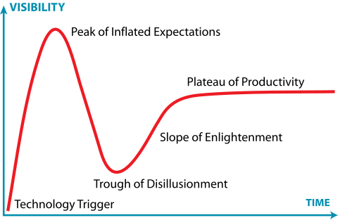
* Plateau: technology gains widespread adoption and users begin to **experience tangible benefits**, **mainstream adoption accelerates**, criteria for evaluating providers become more established
* yield **substantial returns**, successful integration

For example, generative AI? what we address and should address?

<https://www.gartner.com/en/newsroom/press-releases/2023-08-16-gartner-places-generative-ai-on-the-peak-of-inflated-expectations-on-the-2023-hype-cycle-for-emerging-technologies>

Generative artificial intelligence (AI) is positioned on the Peak of Inflated Expectations on the Gartner, Inc. Hype Cycle for Emerging Technologies, 2023, projected to reach transformational benefit within two to five years. Generative AI is encompassed within the broader theme of emergent AI, a key trend on this Hype Cycle that is creating new opportunities for innovation.

“The popularity of many new AI techniques will have a profound impact on business and society,” said Arun Chandrasekaran, Distinguished VP Analyst at Gartner. “The massive pretraining and scale of AI foundation models, viral adoption of conversational agents and the proliferation of generative AI applications are heralding a new wave of workforce productivity and machine creativity.”

“While all eyes are on AI right now, CIOs and CTOs must also turn their attention to other emerging technologies with transformational potential,” said Melissa Davis, VP Analyst at Gartner. “This includes technologies that are enhancing developer experience, driving innovation through the pervasive cloud and delivering human-centric security and privacy.”

“As the technologies in this Hype Cycle are still at an early stage, there is significant uncertainty about how they will evolve,” added Davis. “Such embryonic technologies present greater risks for deployment, but potentially greater benefits for early adopters.”

refer back to lecture slides for this

**UNDERSTANDING THE DIGITAL ECONOMY (IMPORTANT)**

Digital technology is

* representation of information in bits (0 or 1)
* processed by digital devices

Digital Economy <-> IT based economy

Digital Economy is **broader**, includes ecommerce, online platforms, digital payment, cloud computing, data analytics, AI

* **digitalise economic activities**: production, distribution, consumption e.g. electronic transactions
* Digital Technologies -> leverage for EVERY economic activity -> Economic Growth
* B2B and B2C transactions
* digital, mobile & electronic payments, cryptocurrencies, digital wallets
* resource of the digital economy is the **infrastructure that supports it**
  + broadband networks, data centres, cloud services, etc.

**DIGITAL TRANSFORMATION: drivers of digital economy and transformation, link to benefits**

* integration of digital technology into all areas of a business
* fundamentally changing how they operate and deliver value to customers
* innovation in the business model
* AI-equipped Starbucks coffee machine, Nike’s distribution strategy

* hosts: create value from unused assets
* guests: seek experience
* platform: facilitate communication and transaction

Economic Models - Digital technology…

* automates many steps in business processes (formally manual)
* enable decision makers to make more informed decisions
* enable new innovative business processes (collecting, processing, distributing information in more efficient ways)
* transform how the business works, drive new business models

PRODUCTION, one the **most important** economic activities

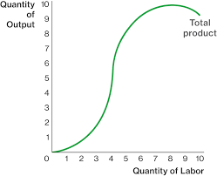

technological changes **shift the curve upward**

**MARKET STRUCTURE**

Digital Players (e.g. FAANG) are a subset of Digital Economy

you know what a market is

* government REGULATES markets by implementing terms and conditions
* 13% of markets consist of illicit transactions

Market Power/Dominance

* ability of a firm/group of firms to **profitably charge prices above the competitive level for a sustained period of time**
* shut out competitors, charge high prices, produce low quality products
* e.g. Google Search, NVIDIA GPUs

Anti-consumer / Anti-competitive -> **less fair, dynamic. innovative** market environment

* e.g. Google lawsuit of using anti-competitive tactics to maintain and extend its monopolies
  + prioritising its own services, users difficulty finding competing products or services
  + intrusive data collection practices, collecting more than necessary
  + “without us, the citizens cannot work” - google (ironically i am typing this on google docs)

Defining the relevant market

* Government: tax and competition regulation
* business: set prices based on demand and supply
* consumer: enjoy incentives for companies to innovate (increased number of substitute)
* e.g. Smukers (grocery market) -> strawberry (healthy market) + jam (general grocery market). Leverage its brand to **dominate both markets**
* Government guidance
  + SSIC - classify economic activities undertaken by economic units
  + NAIC code
* SSNIP
  + minimum level that affects consumer demand, 5-10%
  + raise prices non temporarily -> avoid cases where consumers temporarily stop spending until prices fall again
  + 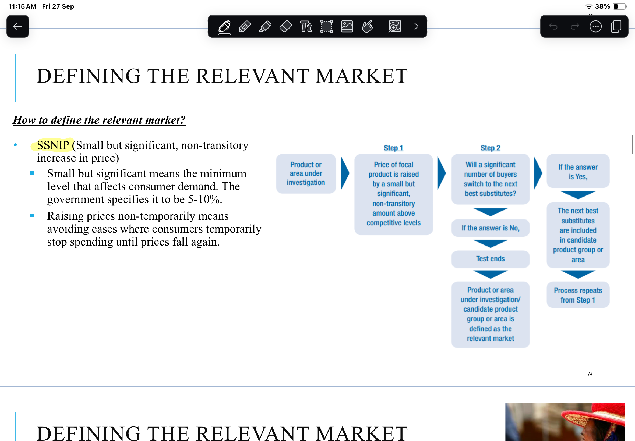
  + Digital economy: difficult to define relevant market
  + case-by-case and service-by-service basis, segment by diverse customer needs and context
  + SSNIP regarding data or free service (rather than money)
  + govt focus on **setting up regulations** and **encourage fair competition** instead of direct intervention

Dual / multi market influence

* Google leverage search engine dominance to gain advantage in advertising space (anti competitive behaviour)
* Kakao - expand beyond messaging service to ride hailing, payment, ecommerce, etc.
  + promote its own service over other competitors
  + stifling competition, limit consumer choice
  + massive productivity loss if servers go down
* Cellophane paradox

IT impact on industry

1. Industry concentration (mid 1990s)
   1. market sales are dominated by one or more businesses
   2. price coordination more feasible as can track what competition is up to
   3. possess large market share
   4. rate of rise is faster in high IT industries than in low IT industries
2. Turbulence
   1. top selling company in one year may not dominate the next
   2. e.g. Nokia vs Apple
   3. consistently more sales turbulence in high IT industries
3. Performance Spread
   1. spread in gross profit margin between 25th percentile companies and 75th percentile companies has grown dramatically in high-IT industries
   2. IT in Amazon creates a widening gap in profit margins vs traditional retailers
   3. significant spread between top and bottom performers in the industry
4. **Market Innovation (IMPORTANT)**
   1. break market boundaries, create unique market terms and conditions
   2. e.g. One day Netflix Pass (paycense) threatens streaming services
   3. novel business model and creation of unique market terms e.g. Numerai
   4. Calico - immortality???

you know what perfect competition is

you know what monopolistic power is

you know what oligopoly is

PRICING STRATEGIES

Determine utility, benefit and expected value to customer using

**Economic Value to Customer (EVC)**

UTILITY: how much value an individual customer / customer segment gets from using a company’s products or services / total satisfaction or benefit derived from consuming a good or service

Customer will buy a certain product only if its value to them **outweighs the value of the closest alternative**

Utility_a > Utility_b

Marginal utility = delta total utility / delta units consumed

User generated content -> valuable source of customer needs

Use AI to capture consumer data

* scrape web to record customer navigational details
* high volume
* update constantly and track over time
* train machine to identify certain keywords and create sentences
* price prediction, integrate sentiment score to predict optimal rental price
* e.g. Airbnb

**PRICE DISCRIMINATION**

1. First degree
   1. personalised (individual) pricing
   2. focus on individual characteristics
   3. charge each customer the **maximum price they are willing to pay**
   4. tailor prices to an **individual’s specific situation**
   5. e.g. airline (skyscanner)
   6. **DYNAMIC PRICING** -> prices fluctuate based on real time supply and demand (not personalised to the individual but adjusts based on market conditions)
   7. producer captures all the consumer surplus, consumer does not receive benefit beyond what they paid for
   8. AI-driven algorithms are black boxes - lack of transparency -> unfair high prices
   9. AI-enabled PD - economic inequalities -> systematically charge higher prices to less informed customers with higher willingness
2. Second degree (versioning)
   1. create different versions of products for the purpose of PD
      1. add more features for the high price
      2. e.g. spotify premium
      3. very easy for digital goods / services
   2. charging consumers a different price for quantity consumed (bulk discount)
   3. bulk discount (non linear pricing), reward cards
   4. value subtracted version of products to target different segments of customers
      1. professional vs student version
      2. deluxe vs standard version
   5. **BUNDLING: Combining two or more products together and charging one price for the bundle**
      1. Second degree PD - different pricing based on quantity / version of a product
      2. **WHY BUNDLE?** 
         1. **perfect PD is difficult (expensive)**
         2. stronger regulation on PD
         3. introduction of new service and product
      3. e.g. Disney plus, HULU, ESPN+
3. Third degree
   1. group pricing based on segmentation
   2. e.g. sephora pink tax
   3. higher prices is regulated by government

AI-enabled price discrimination at more affordable costs

* look into the inputs to the model - what factors it considers

Customers are heterogenous -> different pricing strategies more effective

* extra more surplus from customers
* easier to estimate WTP
* implement different pricing schemes for price discrimination

**LOCK-IN**

* Make customers dependent on them for products and services by making it **hard to switch to a competitor without substantial costs**
* use data-driven advertising models
* less likely to move to smaller competitors due to high switching costs
* CHALLENGING TO LOCK IN:
  + app users are multi-homing, engage with multiple apps for similar services
  + open information reduce barriers to explore alternatives -> less likely to remain loyal
  + service quality is almost identical, no differentiation value

Switching costs

* higher cost of switching, more likely to lock in
* financial costs (price, compensation, incentives)
* non-financial costs (psychological discomfort, time, effort)
* **Total switching cost = cost of stop buying A’s product + B’s costs**
* Provide subsidies or incentives to induce switch - side payments, compensations, gift cards

**Classification of Lock-In (RECALL THIS IN MEMORY)**

1. Contractual commitments
   1. contracts have explicit or implicit damages
   2. switching costs will *go down over the duration of the contract*
   3. e.g. bundling PC hardware with contractual obligation for Internet service provider
   4. customer may no longer be locked in before end of contractual obligation
   5. something about law of diminishing returns
   6. **intentionally make cancellation difficult or subtle for customers to struggle / don’t notice** e.g. Netflix
2. Brand-specific training
   1. switching costs associated with learning increase over time -> users become more familiar and comfortable with an existing system, especially in digital business
   2. psychological comfort (reluctant to leave familiar environment) and learning costs (time and effort required to adopt a new system)
   3. e.g. the entire Adobe suite, AWS cloud services
3. Information and databases
   1. data and format conversion costs, costs of losing data (information related to profile)
   2. migrating data from one database to another requires significant investment in time, resources, manpower
   3. some industries must comply with strict data storage and management regulations
      1. transferring to new provider might require thorough compliance review -> add complexity to cost of switching
4. **Search costs (RELATED TO NETWORK EFFECT)**
   1. need to compare prices, coverage options, exclusions, deductibles, premiums etc.
   2. e.g. insurance - time consuming to compare different providers and policies
   3. AWS vs Google Cloud/MS Azure -> high search costs associated with evaluating, understanding, switching to another provider
   4. consider factors e.g. convenience, product range, prices, service quality
      1. if **platform ecosystem** offers a **comprehensive solution** - integrate multiple features, sellers, … in one place -> less likely to search for alternatives
5. Loyalty programs (not just for lock in, for network effect too)
   1. reward customers for repeat purchase and patronage
   2. e.g. airline frequent flyer programs
   3. key driver in profit CASH COW
   4. Digital technologies -> leverage real time tracing and digital incentive feature, identify loyal vs non loyal customers
      1. personalised reward
      2. gamification feature
      3. customer relationship management systems

MARKET FAILURE (1x essay question)

Technological lock in can lead to market inefficiencies, e.g. MS and Tesla where dominant standards / products become entrenched despite potentially better alternatives

**NETWORK EFFECT**

[description of externality]

* Phenomenon by which the **value or utility a user derives** from a good or service **depends on the number of users** in general and ***user connection*** in particular, in the product / service network
* typically positive -> given user deriving more value from a product as more users join the same network
* Congestion: negative network effect - too many users slow service down, reduce utility
* every platform relies on MATCHMAKING
* **connections between users >>> number of users**
* 2 sided network
  + delivery: restaurant <-> customer <-> rider matchmake each other
  + role is different, power gained is not the same
* strong network effects -> POSITIVE EXTERNALITY
  + social media growth -> number of users on the platform grows
  + POSITIVE FEEDBACK LOOP

Empirical evidence of network effect (essay question)

Direct-benefit signal

Positive feedback loop

E.g. Skype vs Zoom -> disrupting existing networks

Zoom is built on frictionless communication, remove the need to exchange personal account information

Threat of being replaced by other video-conferencing services -> **shift Zoom business model to become a workplace platform**, expand product offerings to include other tools

Key Takeaways

* understand network structure and associated network effects
* break free from cycle
* balance growth while maintaining user experience
* exclusive network is not always bad

Risk and Information Asymmetry (less emphasis)

* RISK: possibility of loss/injury
* cannot change Risk Appetite and Risk Aversion
* uncertain product quality
  + consumer willingness to pay lower
    - few high quality goods sold
      * market failure - negative externality - loss of consumer welfare
* REDUCE RISK AND DECREASE UNCERTAINTY
  + informative advertising (SCREENING)
  + free trials
  + money back guarantee / return policy
  + third party certificate
  + third party review (SIGNALLING)
* Investors try to collect information to **maximise returns** while **reducing risks**
* adverse selection -> market failure